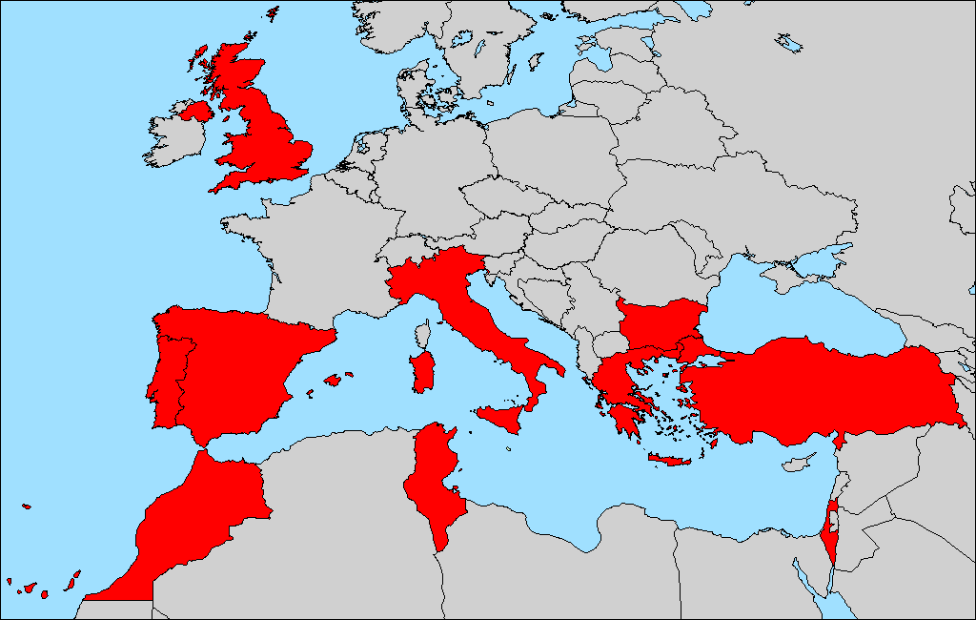
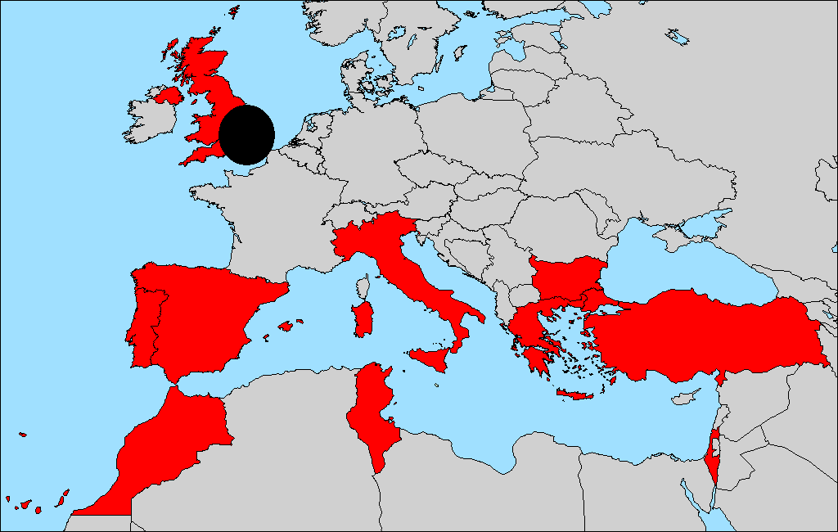
Institute for Animal Health (IAH), UK
Newsletter No. 3
MAY 2002
Bluetongue and Other Culicoides-
Transmitted Diseases Threatening the EU

Partner 1

Finding new partners
There has been considerable progress in trying to find new partners elsewhere in Europe and North Africa. We have been contacted by a researcher, Professor Bakrach, from Serbia. We hope to persuade him to do some trapping in this potentially interesting area for Culicoides and BT.
We have been in contact with Martin Hall of the Natural History Museum who is seeking funding for a survey of screwworm flies in farms in Crete. We have suggested that he trap for Culicoides at the same farms.
Dr Baylis is in contact with an undergraduate student at Oxford University, Thomas Ross, who is trying to organise some trapping for us in Libya.
An employee of CIRAD (Montpellier) Francois Roger, is doing an MSc at the London School of Tropical Medicine. He heard Dr Baylis give a talk on BT and approached him about the situation in Corsica. As a result, his MSc project has been developed as a GIS modelling exercise on BT and C. imicola in Corsica. He will work with TALA (Oxford) and we hope to produce predictive maps for northern Spain, southern France and northern Italy based on areas of suitable climate identified in Corsica. We shall also be able to use the Corsica data in the main BT project.

Visits
We (Dr Purse and Dr Simon Carpenter) will visit Bulgaria in late June and early July to carry out vector competence experiments on C .obsoletus and C. pulicaris.

Finances and reports
The first year's scientific report was delivered to the Commission on February 14th 2001 and was accepted by them in early May. We would like to thank all the partners for contributing to it so effectively.
As many of you know, there has been a delay in the delivery of the second tranche of money from the Commission. Our financial officer (Mike Baker) sent the consolidated cost statements to the Commission in late February but the Commission is now apparently having difficulty finding them. Mike is in close contact with the Commission's financial department and hopes to resolve the situation very soon. However, the arrival of the second tranche of money is dependent on such a resolution and we will contact you all when we have further information.

Staff change
As mentioned in the previous newsletter, Dr Wittman left the project at the beginning of November 2001. She was replaced at IAH in April by Dr Beth Purse.

Drs Philip Mellor, Matthew Baylis and Beth Purse

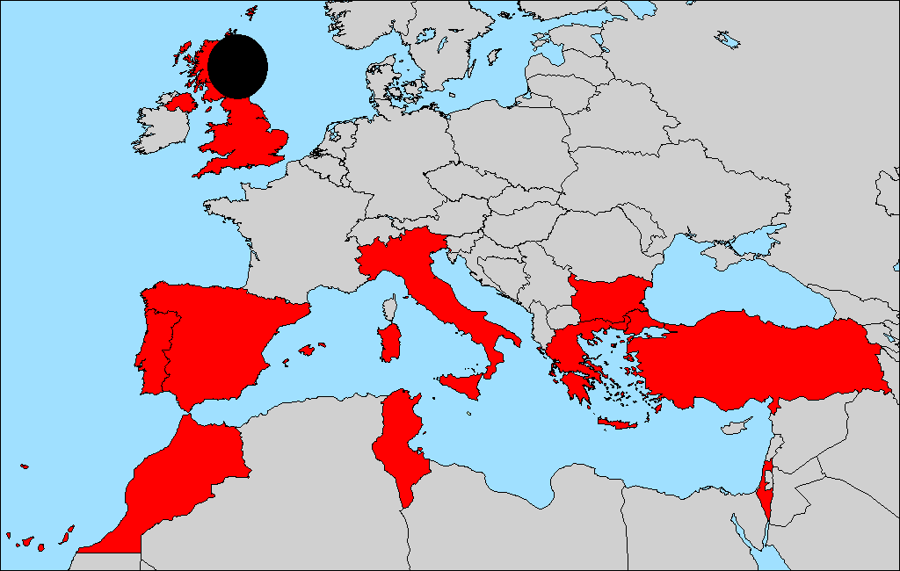
University of Aberdeen,
UK

Partner 2

Dr Damien Nolan has taken over from Dr Rob Cruickshank on the project. Damien previously worked on the "Development of a microsatellite-based genetic profiling system for the salmon louse, Lepeophtheirus salmonis" as part of his Ph.D. work at the Department of Microbiology, National University of Ireland, Galway. In Aberdeen he is continuing the development of molecular markers to measure gene flow in Culicoides imicola, focusing on the mitochondrial genes Cytochrome oxidse I (COI) and NADH dehydrogenase subunit 5 (ND5), and on another PCR-based method called EPIC-PCR (Exon priming intron crossing-PCR). In addition he will be co-ordinating the dispatching of items necessary for carrying out the trapping of samples by different partners involved in this aspect of the work in the coming summer.

Dr Damien Nolan

TALA Research Group,
University of Oxford, UK
Partner 3

Recent activities at Oxford have involved the acquisition and processing of satellite imagery for use in the bluetongue predictive model. One kilometre spatial resolution NOAA Advanced Very High Resolution Radiometer (AVHRR) imagery of Europe and North Africa have been downloaded from the US Geological Survey data centre covering the period from April 1992 to April 1996. The data has been processed to produce monthly images of Normalised-Difference Vegetation Index (NDVI), Middle Infrared (MIR), Land Surface Temperature (LST) and Air Temperature (TAIR), which were then maximum value composited to reduce the effects of cloud covered pixels. These images were temporally Fourier processed to extract information about the seasonal cycles of the NDVI, MIR, LST and TAIR. Finally, the Fourier processed imagery were geo-rectified and registered to Latitude-Longitude, ready for use with the insect catch data in the predictive modelling stage. In addition to the AVHRR data, 1 km spatial resolution SPOT Vegetation imagery of Europe and North Africa covering the period April 1998 to September 2001 were acquired. These were processed in the same way as the AVHRR imagery to produce Fourier processed images of NDVI and MIR. Immediate future work involves producing predictive models based on the complete Portuguese data set, followed by a full predictive model when the remainder of the insect catch data is available.

Dr Andy Tatem

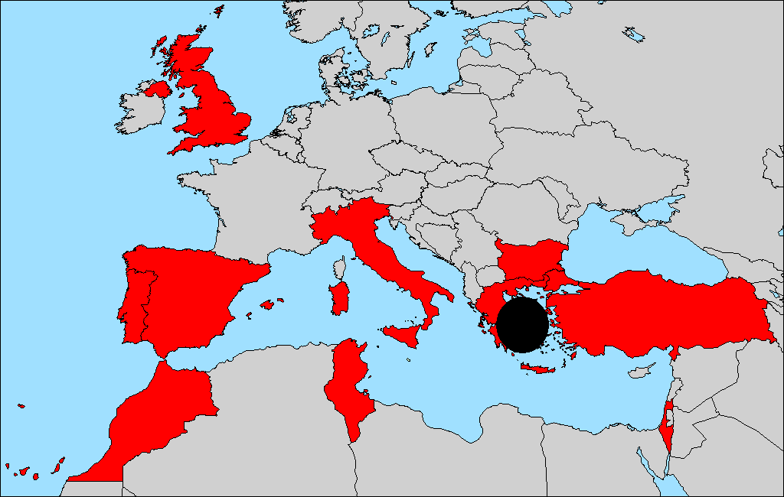
Ministry of Agriculture,
Greece
Partner 4

Nothing to report.

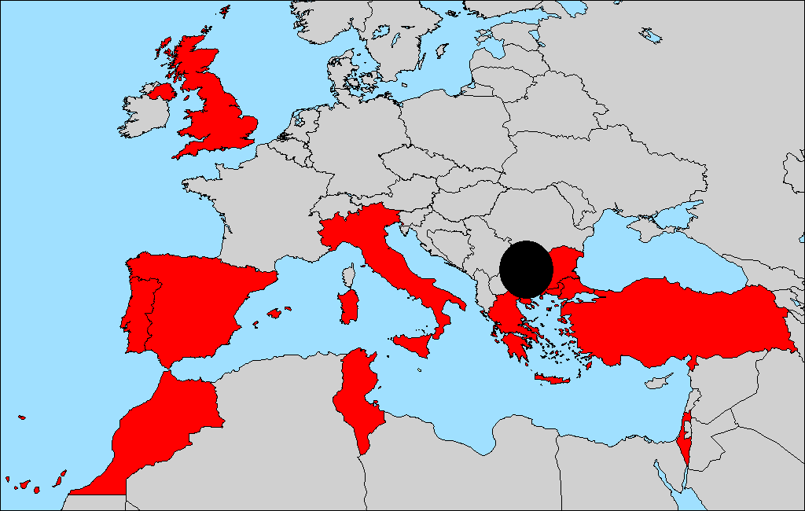
National Diagnostic Veterinary Research Institute, Bulgaria

Partner 5
Between August and November 2001, we collected further Culicodes samples, concentrating our efforts on the regions that have been affected with BTV in Western Bulgaria (bordering F.Y.R. Macedonia and Serbia), in Sofia, Kiustendil amd Blagoevgrad. These samples have been sent to partner 1 for identification.
To determine when activity of Culicoides begins in spring, we began trapping early in March 2002 in two villages (Vaksevo and Bersin) in the Kiustendil district. These villages were affected by BTV last year and sampling will continue throughout the summer. Sampling will begin in the whole of the territory in June 2002, including districts in Southern Bulgaria (scheduled to have been trapped last year) and Northern Bulgaria.

Drs Nedelcho Nedelchev & Georgi Georgiev

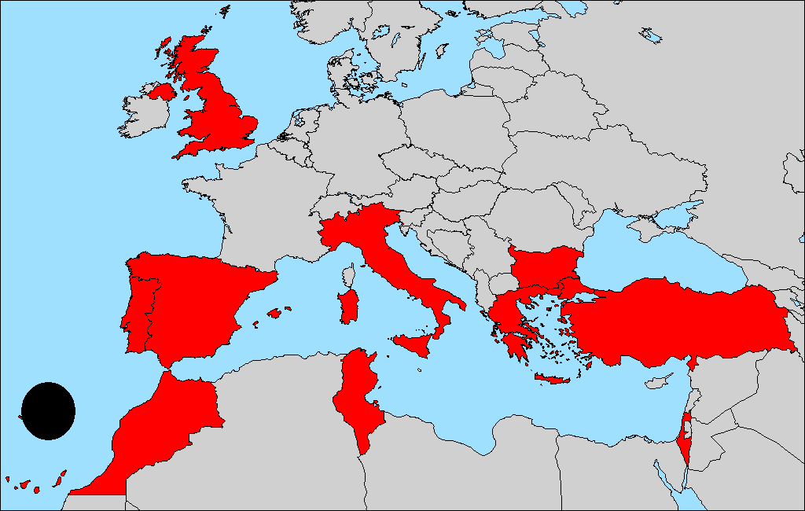
Universidade da Madeira,
Portugal

Partner 6

Further winter collections were not made this year due to the late arrival of funds from the General Co-ordinator. There is nothing else to report at present.

Dr Ruben Capela

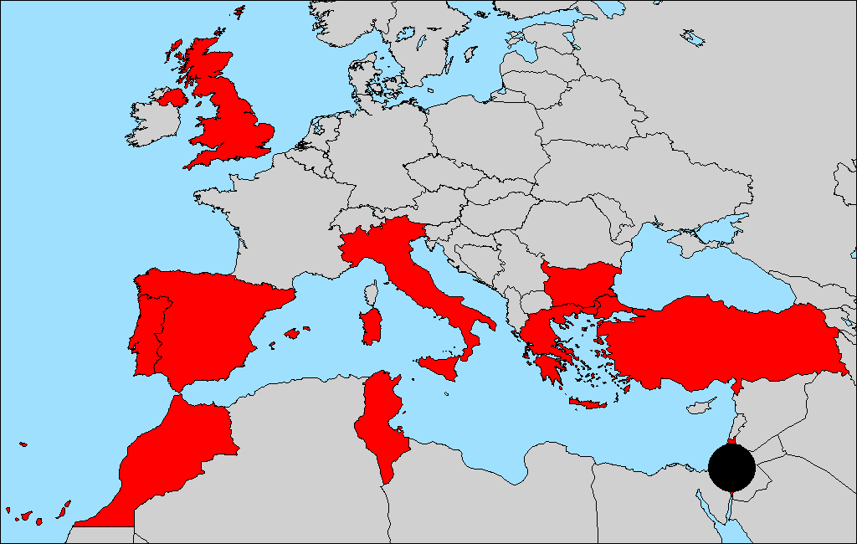
Kimron Veterinary Institute, Israel

Partner 7

There is nothing to report at present except that I am trapping Culicoides throughout out the year (including winter) as usual.

Dr Yehuda Braverman

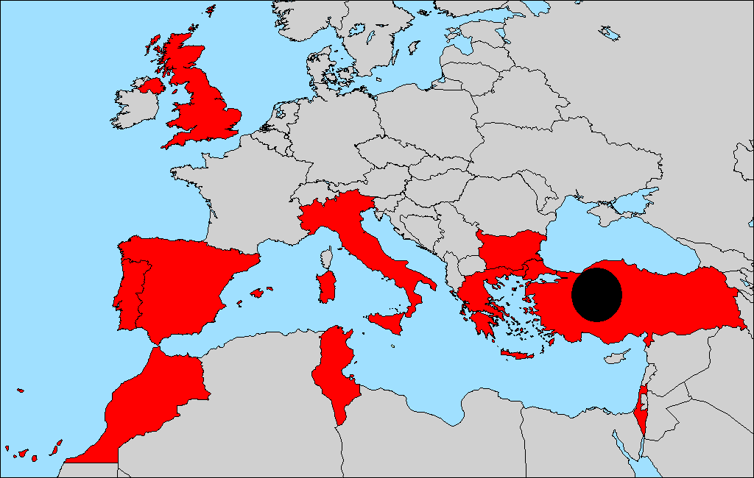
University of Ankara,
Turkey
Partner 8

We did not perform any winter collections in European Turkey (Thrace) as there was an incredibly cold winter and many places were frozen for several months. Last month (April 2002), we started regular collections of insects and blood samples in two sentinel farms located in two distinct quadrats on the Egean coast. The Thrace and Aegean Culicoides survey will be carried out after August this year (after summer school has finished).

Dr Aykut Ozkul

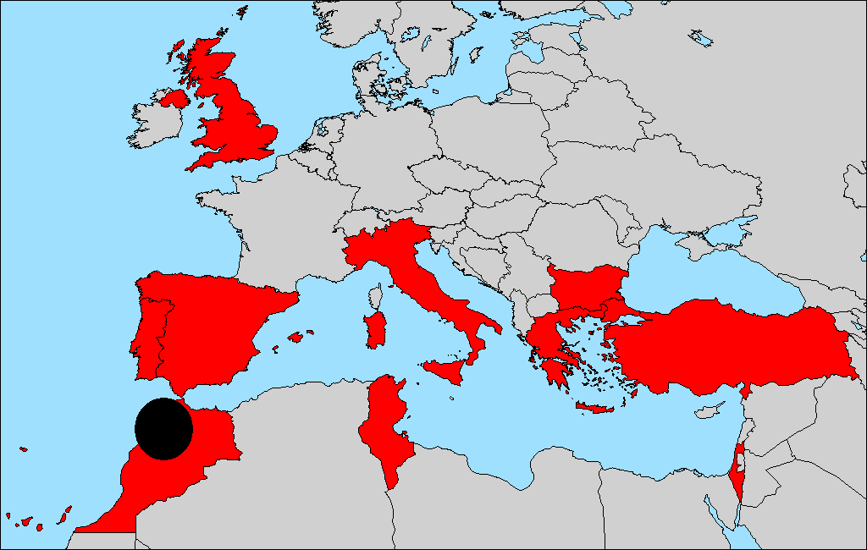
Ministry of Agriculture, Rural Development & Fisheries, Morocco
Partner 9

Nothing to report. Partner 1 is currently analysing Culicoides samples collected in 44 sites between June and September 2001.

Dr Youssef Lhor

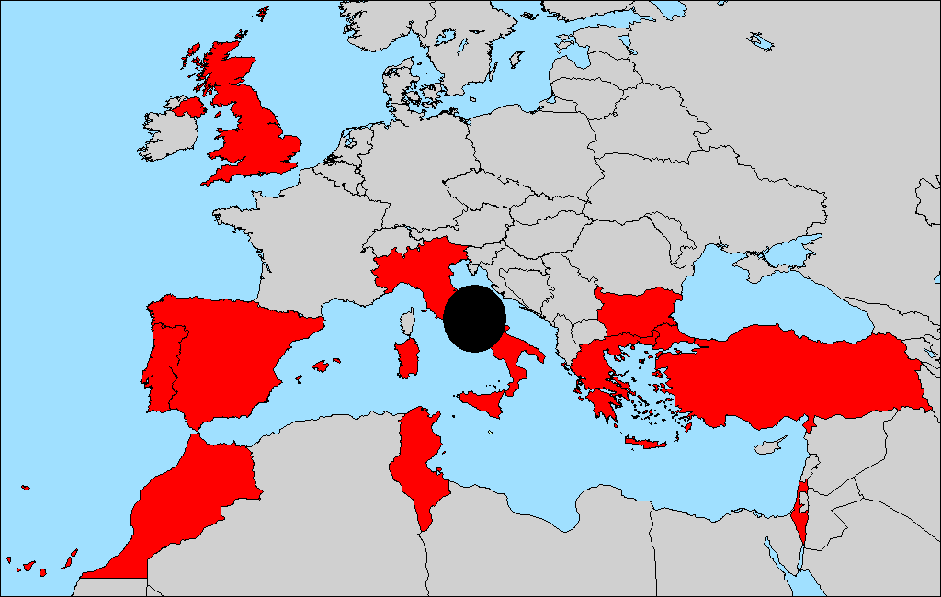
Instituto Zooprofilattico Sperimentale, Italy

Partner 10

After several communications, Partner 1 has now arranged a meeting with Dr Caporale, for June 17th in Teramo.

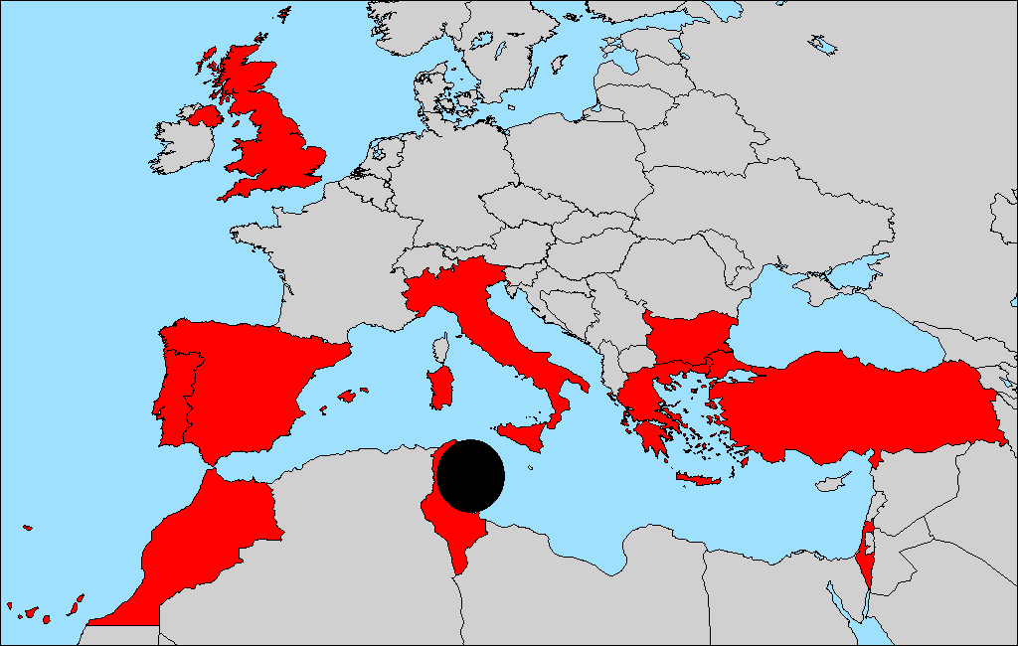
Institut de la Recherche Veterinaire, Tunisia
Partner 11

Nothing to report.

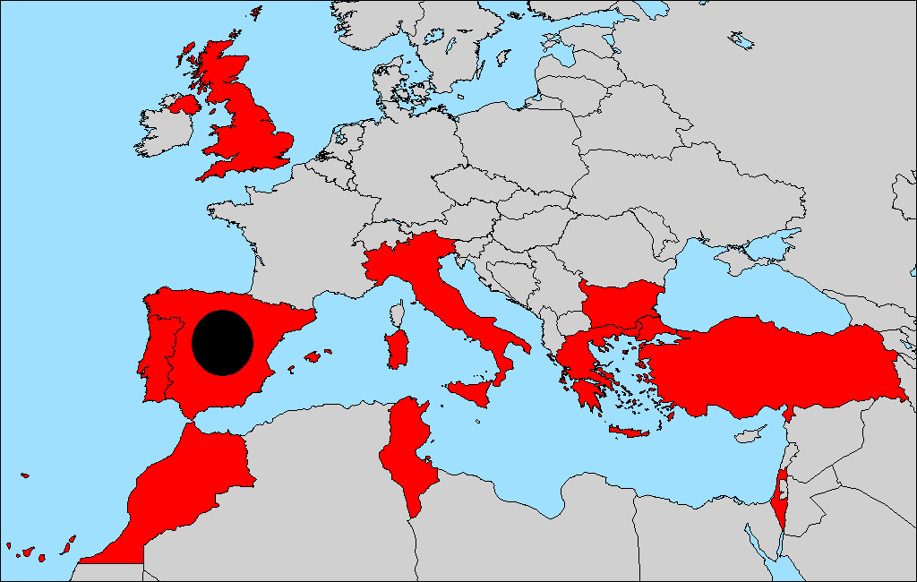
Centro de Investigacion en Sanidad Animal, Spain

Subcontractor of Partner 1

Trapping on the east coast of Spain is due to start this month (May 2002). Each community is organising their own sampling and I will be carrying out some of the identification. I am hoping to be able to establish the range of climatic and environmental conditions found where Culicoides are abundant in Spain.

Ms Amparo Martinez

Other

Recent Publications by Partners
Baylis M., Mellor P.S., Wittmann E.J. & Rogers D.J. Prediction of areas around the Mediterranean at risk of bluetongue by modelling the distribution of its vector using satellite imaging. Vet. Rec. 150 (13): 404-404.
Baylis, M. (2002). The Re-emergence of Bluetongue. Vet. J. 163: 1-2.
Georgiev, G., Martinov, S. & Veleva. E. (2001) Studies on the distribution and epizootiology of the Bluetongue disease in ruminants in Bulgaria Biotech Biotechnol. Eq. 15 (1): 79-86.
Georgiev, G., Martinov, S. & Veleva. E. (2001) First epizootic of Bluetongue disease in Bulgaria. Dynamics of immunity, virus carriage amd reservoirs of infection. Biotech. Biotechnol. Eq. 15 (2): 67-72.
Georgiev, G., Martinov, S. & Veleva. E. (2001) Serological tests for diagnosis of Bluetongue disease in ruminants and comparative assessment of their reliability. Biotech Biotechnol. Eq. 15 (2): 80-85.
Mellor P.S. & Wittmann E.J. (2002) BTV in the Mediterranean Basin 1998-2001, Vet. J. 163:
Моргиеп, Г., Неделчев, Н., Иванов, Емилија Велова. Second epizooty of Bluetongue disease in Bulgaria Симпоэијум “IV Јуѓословенски епиэоотиолошки дани” 360 рник реФерата иа кратких садаржаја Маггарушка Самьа, 3-6 апрепа 2002 Југоспавия с. 99-102.
Nedelchev, N., & Georgiev, G. (2002) Culicoides sp. Surveillance in Bulgaria during the year 2001. Симпоэијум “IV Јуѓословенски епиэоотиолошки дани” 360 рник реФерата иа кратких садаржаја Маггарушка Самьа, 3-6 апрепа 2002 Југоспавия с. 107-112.
O’Connell, L. (2002) Entomological aspects of the transmission of arboviral diseases by Culicoides biting midges, Unpublished PhD thesis. Institute for Animal Health.
Paweska J.T., Venter G.J., Mellor P.S. (2002) Vector competence of South African Culicoides species for bluetongue virus serotype 1 (BTV-1) with special reference to the effect of temperature on the rate of virus replication in C. imicola and C. bolitinos. Med. Vet. Entomol. 16 (1): 10-21

Contact Details
Could everyone re-check their contact details and let Dr Purse know if any changes are required? The revised list will then be sent out to everyone.

Next Project Meeting
Hopefully, Ruben Capela and Isabel Pena, will be hosting the next meeting, in Madeira, before the end of the year.

Next Newsletter
December 2002

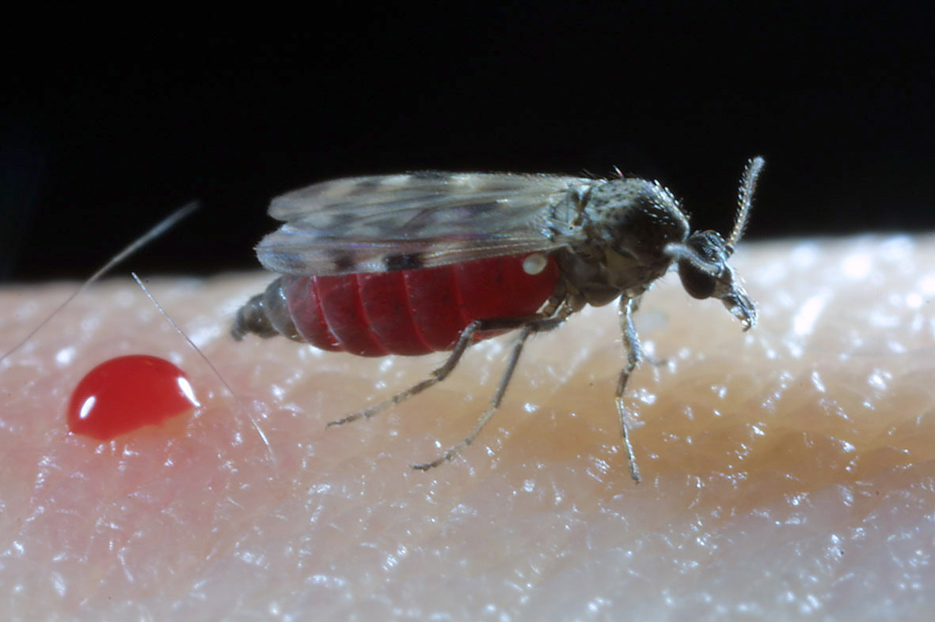
Figure 1. Female Culicoides imicola shortly after feeding. Copyright IAH 2002.

Contact Details

Partner  (Country) | Name | Address | Telephone | Fax | Email
1 | Matthew Baylis | Institute for Animal Health, Compton, Newbury, Berkshire, RG20 7NN, UK. | +44 (0) 1635 578411  Extn 2312 | +44 (0) 1635 577237 | Matthew.Baylis@bbsrc.ac.uk
(UK) | Philip  Mellor | Institute for Animal Health, Ash Road, Pirbright, Surrey, GU24 0NF, UK. | +44 (0) 1483 232441  Extn 1150 | +44 (0) 1483 232448 | Philip.Mellor@bbsrc.ac.uk
 | Beth  Purse | Institute for Animal Health, Ash Road, Pirbright, Surrey, GU24 0NF, UK. | +44 (0) 1483 232441  Extn 1021 | +44 (0) 1483 232448 | Beth.purse@bbsrc.ac.uk
 | Damien  Nolan | Department of Zoology, University of Aberdeen, Tillydrone Avenue, AB24 2TZ, UK. | +44 (0) 1224 272868 | +44 (0) 1224 272396 | d.nolan@abdn.ac.uk
2  (UK) | John  Dallas | Department of Zoology, University of Aberdeen, Tillydrone Avenue, AB24 2TZ, UK. | +44 (0) 1224 272273 | +44 (0) 1224 272396 | j.dallas@abdn.ac.uk
 | Jenny Mordue | Department of Zoology, University of Aberdeen, Tillydrone Avenue, AB24 2TZ, UK. | +44 (0) 1224 272883 | +44 (0) 1224 272396 | a.j.mordue@abdn.ac.uk
3  (UK) | David  Rogers | TALA Research Group, Department of Zoology, University of Oxford, South Parks Road, Oxford, OX1 3PS, UK. | +44 (0) 1865 271234 | +44 (0) 1865 310447 | david.rogers@zoology.oxford.ac.uk
 | Andy  Tatem | TALA Research Group, Department of Zoology, University of Oxford, South Parks Road, Oxford, OX1 3PS, UK. | +44 (0) 1865 271269 | +44 (0) 1865 310447 | andy.tatem@zoology.oxford.ac.uk
 | Olga  Mangana | Laboratory of Virology, Centre of Athens Veterinary Institutions, Ministry of Agriculture, 25 Neapoleos Street, 153 10, Agia Paraskevi, Athens, Greece. | +30 1 6011499 | +30 1 6011499 | viruslab@ath.forthnet.gr
4 | Kiki  Nomikou | Laboratory of Virology, Centre of Athens Veterinary Institutions, Ministry of Agriculture, 25 Neapoleos Street, 153 10, Agia Paraskevi, Athens, Greece. | +30 1 6011499 | +30 1 6011499 | viruslab@ath.forthnet.gr
(Greece) | Dionisis  Panagiotatos | Department of Infectious Diseases, Epidemiology & Documentation, Central Veterinary Administration, Ministry of Agriculture, 2 Acharnon Street, 101 76, Athens, Greece. | +30 10 2125719 | +30 1 8229188/ 8252614 | vetserv@ath.forthnet.gr
 | Michael  Patakakis | Laboratory of Parasitology, Centre of Athens Veterinary Institutions, Ministry of Agriculture, 25 Neapoleos Street, 153 10, Agia Paraskevi, Athens, Greece. | +30 10 6080838 | +30 1 6399477 | paralab@otenet.gr

Partner  (Country) | Name | Address | Telephone | Fax | Email
 | Georgi  Georgiev | National Diagnostic Veterinary Research Institute, 15 P. Slaveykov Blvd., Sofia 1606, Bulgaria. | +359 2 9521277 | +359 2 9525306 | director@iterra.net
5  (Bulgaria) | Yanko  Ivanov | National Diagnostic Veterinary Research Institute, 15 P. Slaveykov Blvd., Sofia 1606, Bulgaria. | +359 2 9521277 | +359 2 9525306 | director@iterra.net
 | Nedelcho  Nedelchev | National Diagnostic Veterinary Research Institute, 15 P. Slaveykov Blvd., Sofia 1606, Bulgaria. | +359 2 9521277 | +359 2 9525306 | director@iterra.net
6 | Ruben  Capela | Department of Biology & Geology, Universidade da Madeira, Campus Universitario da Penteada, 9000 Funchal, Madeira, Portugal. | +351 291 705002  Extn. 5380 | +351 291 705399 | rcapela@uma.pt
(Portugal) | Isabel  Pena | Department of Biology & Geology, Universidade da Madeira, Campus Universitario da Penteada, 9000 Funchal, Madeira, Portugal. | +351 291 705002  Extn. 5380 | +351 291 705399 | ipena@uma.pt
7  (Israel) | Yehuda  Braverman | Department of Parasitology, Kimron Veterinary Institute, PO Box 12, 50250, Bet Dagan, Israel. | +972 3 9681634 | +972 3 9681753 | ybrav_vs@netvision.net.il
8 | Ibrahim  Burgu | Faculty of Veterinary Medicine, University of Ankara, Diskapi, 06110 Ankara, Turkey. | +90 312 3170315  Extn 212 | +90 312 3164472 | No email at present
(Turkey) | Aykut  Ozkul | Department of Virology, Faculty of Veterinary Medicine, University of Ankara, Diskapi, 06110 Ankara, Turkey | +90 312 3170315  Extn 364 / 255 | +90 312 3164472 | aykut.ozkul@veterinary.ankara.edu.tr
9  (Morocco) | Youssef  Lhor | Department of Livestock, Ministry of Agriculture, Rural Development & Fisheries, Place Chefchaouni, Quartier Administratif, Rabat, Maroc.  Also  Laboratoire National d’Epidimiologie et des Zoonoses, Rabat Instituts, PO Box 6472, 10000 Rabat, Maroc. | +212 37 765077  +21261 592687 | +212 37 764404 | youssef_lhor@yahoo.fr

Partner  (Country) | Name | Address | Telephone | Fax | Email
 | Paolo  Calistri | National Reference Centre for Exotic Diseases, Instituto Zooprofilattico Sperimentale dell’Abruzzo e del Molise ‘G. Caporale’, Via Campo Boario, 64100 Teramo, Italy. | +39 0861 3321 | +39 0861 332251 | p.calistri@izs.it
10 | V. Caporale | Instituto Zooprofilattico Sperimentale dell’Abruzzo e del Molise ‘G. Caporale’, Via Campo Boario, 64100 Teramo, Italy. | +39 0861 332279 | +39 0861 332251 | caporale@izs.it
(Italy) | Mauro  Di Ventura | Instituto Zooprofilattico Sperimentale dell’Abruzzo e del Molise ‘G. Caporale’, Via Campo Boario, 64100 Teramo, Italy. | +39 0861 332235 | +39 0861 332251 | mdiventu@izs.it
 | Maria  Goffredo | National Reference Centre for Exotic Diseases, Instituto Zooprofilattico Sperimentale dell’Abruzzo e del Molise ‘G. Caporale’, Via Campo Boario, 64100 Teramo, Italy. | +39 0861 3321 | +39 0861 332251 | m.goffredo@izs.it
11  (Tunisia) | Salah  Hammami | Laboratory of Virology, Institut de la Recherche Veterinaire, Rue Djebel Lakhdhar la Rabta, 1006 Tunis, Tunisia. | +216 1 562602/ 564321/ 571489 | +216 1 569692 | hammami.salah@iresa.agrinet.tn
 | Javier  Lucientes  Curdi | Veterinary Faculty, University of Zaragoza, Miguel Servet, 177, 50013 Zaragoza, Spain. | +349 7 6761617  +349 7 6761560 | +349 7 6761612 | jlucien@posta.unizar.es
Subcontractor of partner 1 (Spain) | Amparo  Martinez  Salvador | Centro de Investigacion en Sanidad Animal, Instituto Nacional de Investigacion y Technologia Agraria y Alimentaria, 28130 Valdeolmos, Madrid, Spain. | +349 1 6202300  Extn 19 / 21 | +349 1 6202247 | salvador@inia.es
 | Jose Manuel  Sanchez  Vizcaino | Centro de Investigacion en Sanidad Animal, Instituto Nacional de Investigacion y Technologia Agraria y Alimentaria, 28130 Valdeolmos, Madrid, Spain. | +349 1 6202300 | +349 1 6202247 | vizcaino@inia.es

